ER Diagram 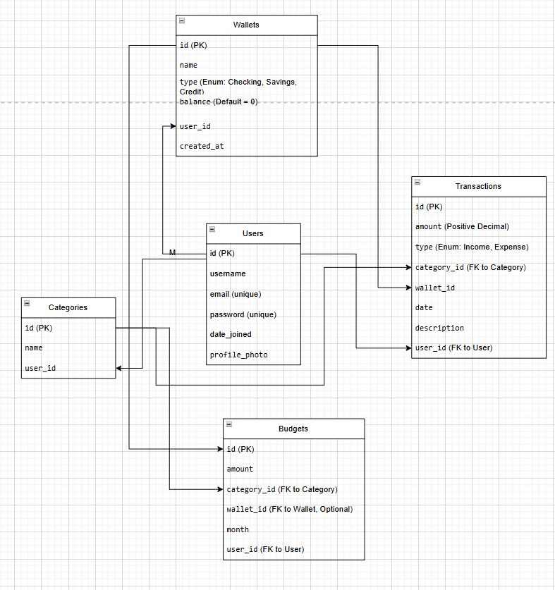

#### **Indexes & Constraints**

* **Primary Keys:** id for all tables
* **Foreign Keys:** user_id, wallet_id, category_id
* **Unique Constraints:** username, email
* **Checks:** balance >= 0, amount > 0

## **2. API Endpoints**

### **Users API**

* POST /api/users/register/ – Register a new user
* POST /api/users/login/ – Log in a user
* GET /api/users/profile/ – Get user profile

### **Wallets API**

* GET /api/wallets/ – List all wallets for the user
* POST /api/wallets/ – Create a new wallet
* GET /api/wallets/{id}/ – Fetch wallet details
* PUT /api/wallets/{id}/ – Update wallet details
* DELETE /api/wallets/{id}/ – Delete a wallet (if no transactions exist)

### **Transactions API**

* GET /api/transactions/ – List all transactions
* POST /api/transactions/ – Add a transaction
* PUT /api/transactions/{id}/ – Update a transaction
* DELETE /api/transactions/{id}/ – Delete a transaction
* GET /api/transactions/?wallet_id={id} – Filter transactions by wallet

### **Budgets API**

* GET /api/budgets/ – List all budgets
* POST /api/budgets/ – Add a new budget
* PUT /api/budgets/{id}/ – Update a budget
* DELETE /api/budgets/{id}/ – Delete a budget

### **Dashboard API**

* GET /api/dashboard/summary/ – Fetch total income, expenses, and balance
* GET /api/dashboard/summary/?wallet_id={id} – Fetch summary for a specific wallet
* GET /api/dashboard/categories/ – Spending breakdown by category